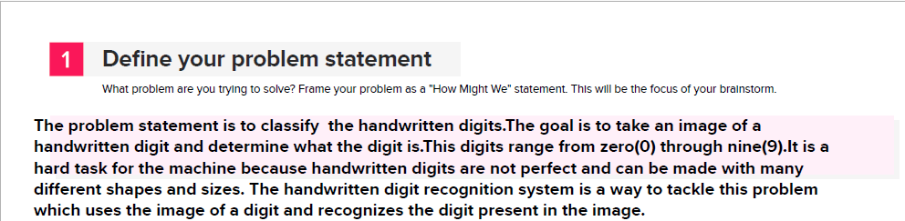DEFINE YOUR PROBLEM STATEMENT

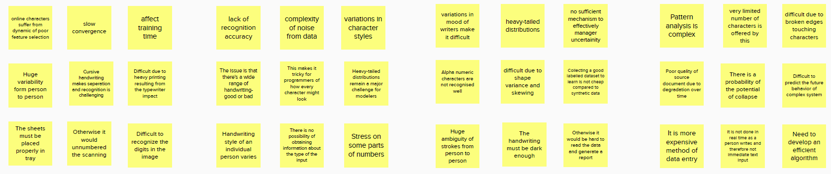BRAINSTORM



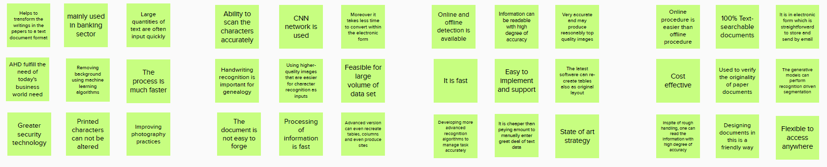

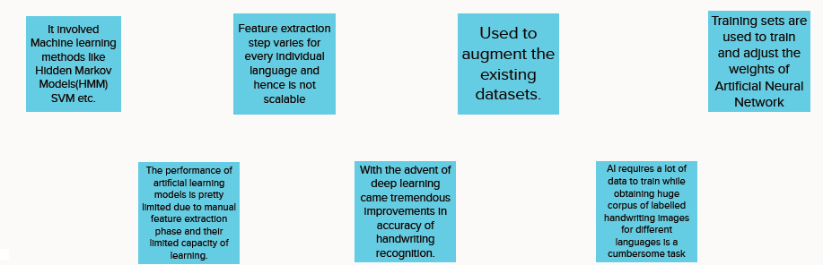GROUP IDEAS

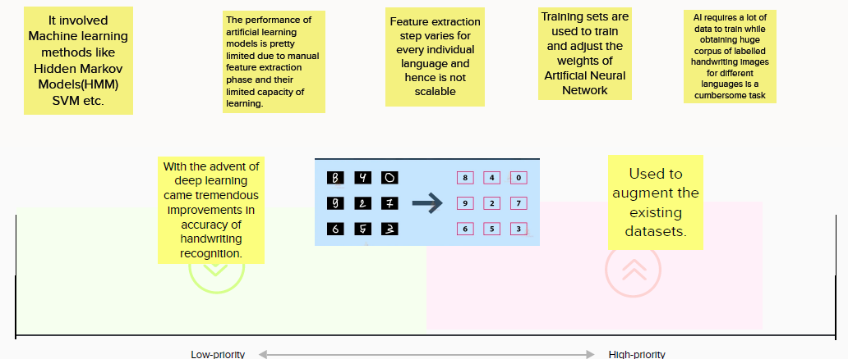PRIORITIZE IDEAS